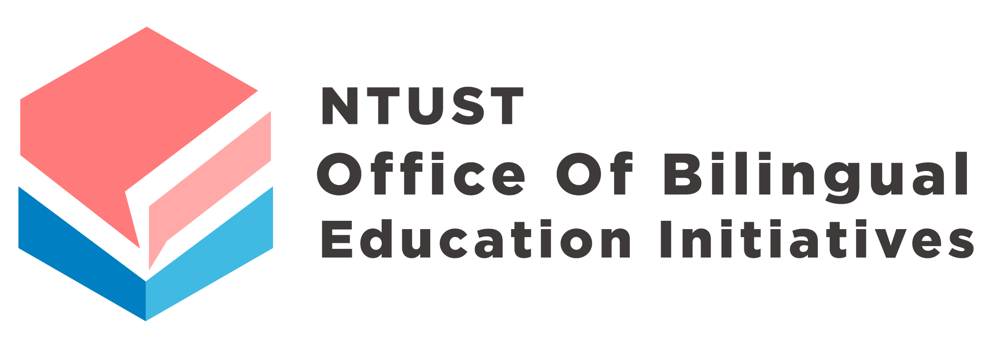

EMI Teaching Skills Enhancement Rewards Application Form

Course Title： | _____________________________
Instructor： | _______________________ (Signature)
Department Supervisor： | _______________________ (Signature)
College Supervisor： | _______________________ (Signature)
Date of Application： | ___________________ (yyyy/mm/dd)

Notice：
- Instructors should upload the application documents to the cloud storage and provide the Office of Bilingual Education Initiatives (OBEI) with the download link. The application documents will be reviewed by the committee listed in electronic form.
- After the completion of the application form, the instructor must submit the hard copy with the signature on the cover page to the OBEI within the specified deadline.
- Please refer to the application form's last page for the application submission guidelines.

1. Reference for Evaluation Criteria
- Course Objectives and Design (30%)
- EMI Teaching Skills Enhancement (40%)
- Student Learning Outcomes or Achievements (30%)
2. Review Materials
Part One: EMI Course Information
Course Semester | _____academic year _____semester |  | Course Title
Course No. |  |  | Course Department
Required/  Elective |  |  | Course Hours
Credit Hours |  |  | Course Level
Number of Enrolled Students |  |  | Classroom Location
Instructor Information  (multiple instructors should be listed separately) | Name |  | Tel.
 | Position Title |  | E-mail
 | □ Full-time □ Contract-based  □ Part-time |  | Affiliated Department
Application Document  Download URL | Instructors should upload the application documents to the cloud storage (please refer to the submission guidelines on the last page) and share the shortened download URL below (the common URL shortener: https://reurl.cc/main/tw).  Download URL：
Is this an EMI course | □ Yes (Only the courses that meet the criteria for the EMI incentive program of NTUST are eligible for application)
Record of  Rewards | The instructor should indicate whether this course has received any teaching rewards in the past years:  □ No, this course has not received any rewards. (Please proceed directly to the second part)  □ Yes, this course has previously received EMI Teaching Skills Enhancement Rewards or Innovative Teaching Awards. (Please continue to complete the following information)  Note: The instructor should explain the differences in the course content between this application and the two most recent ones with rewards within the past three years. In addition to the comprehensive explanations, please specifically focus on the differences in EMI teaching techniques enhancement (e.g., Are there any updates in teaching materials and lesson plans? Are there any attempts to different teaching themes?). Please provide explanations of no less than 300 words. The instructor should also provide the application forms for the semester in which the instructor was rewarded for the committee’s reference (Please refer to the last page of the application form for the submission guidelines).
  The semester of being rewarded | The received reward | Explanation of content differences
Video Authorization Consent | The instructor agrees to share the audiovisual recordings in the application on the digital platforms of NTUST and the OBEI.  □ Agree

Part Two: EMI Course Planning and Design
Course Objectives
Course Characteristics
Course Outline
Prerequisite Knowledge for Enrolled Students
Explanation of EMI Teaching Skills Enhancement | (Please describe in detail the specific teaching techniques and innovative features adopted in this course, such as lesson preparation, lesson plan design, course facilitation, classroom management, group discussions, project presentations, assessment methods, etc. The description should be at least 300 words.)
Part Three: EMI Course Achievements and Review
The Influence and Effectiveness of EMI Teaching Skills Enhancement | The Influence and Effectiveness of EMI Teaching Skills Enhancement
Reflection and Suggestions after the Implementation of EMI Teaching Skills Enhancement
Course Photos | (Please paste the photos here directly with a minimum of 10 photos)
- Instructors may submit multiple applications, but only one of them will be approved. When instructors apply with the previously rewarded course, the differences between the two applications should be explained.
- The rewarded instructors are obliged to promote relevant school activities, such as experience and achievement sharing, and to share video and audio recordings of the courses on the online platform of NTUST.

Guidelines of Online Submission for EMI Teaching Skills Enhancement Rewards

Please submit the application materials via online cloud storage. The arrangement of the electronic files should be as follows:

The files should include (please organize them into folders):

- EMI Teaching Skills Enhancement Rewards Application Form

The EMI Teaching Skills Enhancement Rewards Application Form by Instructor ○○○ Please upload a Word or PDF file.

- Video Materials

  - A course introduction video of approximately 20 minutes should be provided for the committee’s review. Accepted file formats include mp4, avi, wmv, mov, 3gp, etc. The file size should preferably not exceed 1.5GB. The video quality should be 720p or higher, and it must be properly edited with an intro and outro, and subtitles. Subtitles or sentence-by-sentence captions can be used to highlight key points.
  - When creating a video, the content must include actual classroom teaching as well as lesson presentation. If enhanced EMI teaching skills are used in the course, the application of these techniques must be demonstrated through subtitles or directly in the video.

- Additional Supporting Materials (it is optional, and the instructor can decide whether to provide them based on their circumstances)
Examples: Teacher-student interaction process, student reflections, and feedback, teaching evaluation, a record of awards, a record of teacher-student interaction, etc. For instructors who do not include teaching evaluation, the OBEI will still request it from NTUST for the committee’s reference.

